**University of Balamand**

**Traffic Light with Arrows and Sensor**

By

Rasha Jabbour

Presented to

Mr. Abdel-Menhem Alameddine

Report for Programmable Logic Controllers

Faculty of engineering

**Objective:**

The point of this program is to simulate a traffic light system of two highways intersecting, with a left arrow light from the north side to the east side, and a left arrow light from the west side to the north side, with a sensor situated for the second arrow light.

Inputs:

I1: Sensor

Outputs:

Q1: NR

Q2: SR

Q3: ER

Q4: WR

Q5: NAY

Q6: WAY

Q7: NY

Q8: SY

Q9: EY

QA: WY

QB: NAG

QC: WAG

QD: NG

QE: SG

QF: EG

QG: WG

Relays:

M1: State1

M2: State2

M3: State3

M4: State4

M5: State5

M6: State6

M7: State7

M8: State8

M9: State9

MB: StateRelay

Timers:

T1: 15SEC

T2: 5SEC

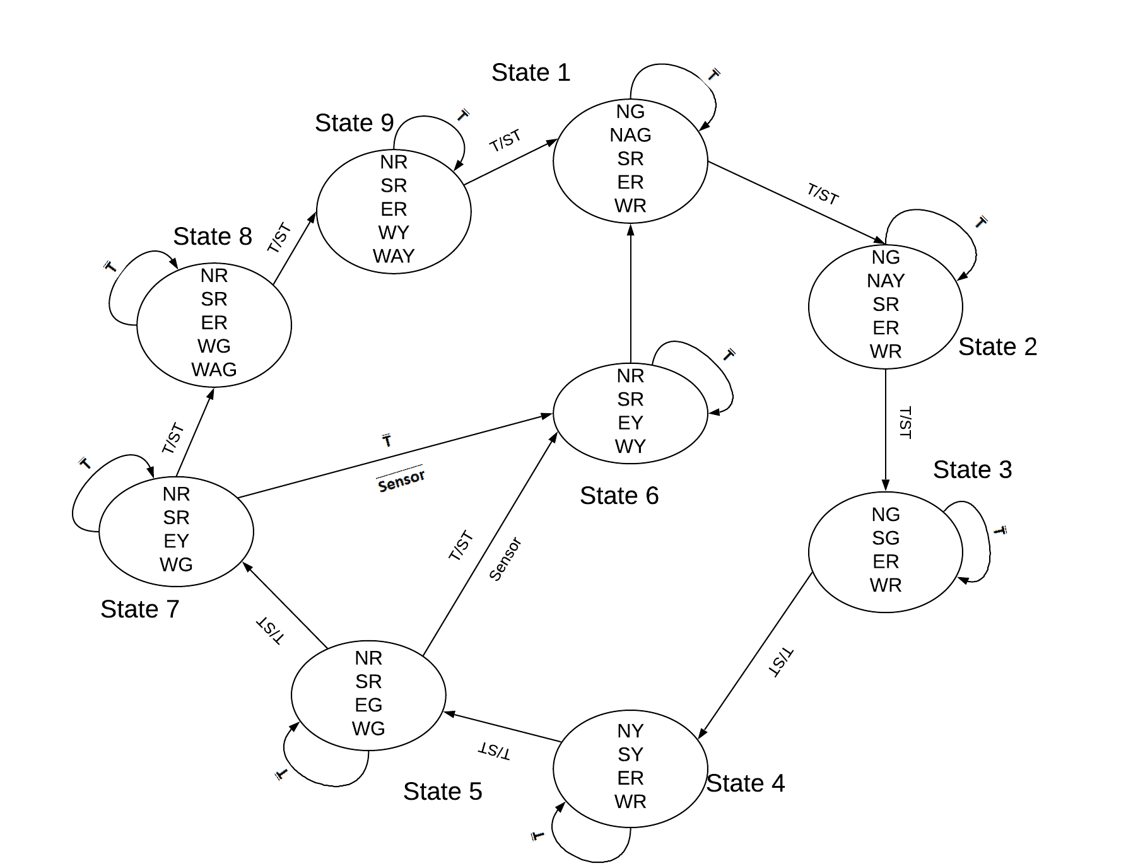**State Machine:**

**How the program works:**

**State 1:**

The program initially starts off with North side and the arrow being green, meaning that cars coming from the north can either traverse to the south of go left to the east. Meanwhile every other traffic light is red meaning no other car is permitted to move.

The 15 second timer starts up as soon as the program starts.

**State 2:**

After the 15 second timer finishes, the north arrow light turns yellow while all the other lights stay the same as in the previous state, meaning that cars coming from the north can still traverse safely to the south, but the ones that want to go left to the east highway need to start slowing down.

The 5 second timer starts up as soon as the 15 second timer ends.

**State 3:**

After the 5 second timer finishes, the arrow light turns red and the south light turns green while all the other lights stay the same, meaning that cars coming from the north can traverse south and vice versa, but all the other cars are not permitted to move.

The 15 second timer starts up as soon as the 5 second timer ends.

**State 4:**

After the 15 second timer finishes, the north and the south lights turn yellow, meaning that the cars traversing north and south need to slow down.

The 5 second yellow timer starts as soon as the 15 second timer ends.

**State 5:**

After the 5 second timer finishes, the north and south lights turn red and the east and west lights turn green, meaning that the cars can traverse from the east side to the west side and vice versa. Meanwhile all the other cars are not permitted to move.

The 15 second timer starts as soon as the 5 second timer ends.

**State 6:**

After the 15 second timer from state 5 finishes, if there are no cars on the sensor for cars wanting to traverse from the west side to the left side, the east and west lights turn yellow, meaning that the cars traversing from east to west and vice versa need to slow down.

The 5 second timer starts as soon as the 15 second timer ends.

**State 7:**

After the 15 second timer from state 5 finishes, if there are cars on the sensor for cars wanting to traverse from the west side to the left side, the east light turns yellow while all the other lights stay the same, meaning that the cars traversing from east to west need to slow down.

The 5 second timer starts as soon as the 15 second timer ends.

If there are no more cars on the sensor during this time, the program jumps from state 7 to state 6.

**State 8:**

After the 5 second timer finishes, the east light turns red while the west arrow light turns green and the other lights stay the same, meaning that cars can only travers from the west side to either the east or north side.

The 15 second timer starts as soon as the 5 second timer ends.

If there are no more cars during this time, the 5 second timer also starts and the program jumps to the next state as soon as one of the timer finishes.

**State 9:**

After either one of the timers finishes, the west arrow light and the west road light both turn yellow, meaning that the cars traversing from the west side to either the east or north side need to slow down.

The 5 second timer starts as soon as the state starts.